Scenario 5: EC2 Instance Store (Ephemeral Storage for High-Speed Processing)
You are working for a media company that processes large video files.
You need extremely fast, temporary storage to process videos quickly before saving results to S3.
For this requirement, you will use EC2 Instance Store volumes (ephemeral NVMe/SSD storage).
instance Store is ideal because:
- ✔ Ultra-high IOPS
- ✔ Very low latency
- ✔ Great for temporary or scratch data
- ❌ Data is lost on stop/terminate
- ✔ Data survives reboot only
Step 1: Launch EC2 with Instance Store
Go to EC2 > Launch Instance
Launch an EC2 instance with instance store support
Use instance types like `c5d`, `i3`, `m5d`, `r5d`, etc. (these have instance store).
DO NOT enable auto-termination protection (so you can test data loss on stop/terminate).
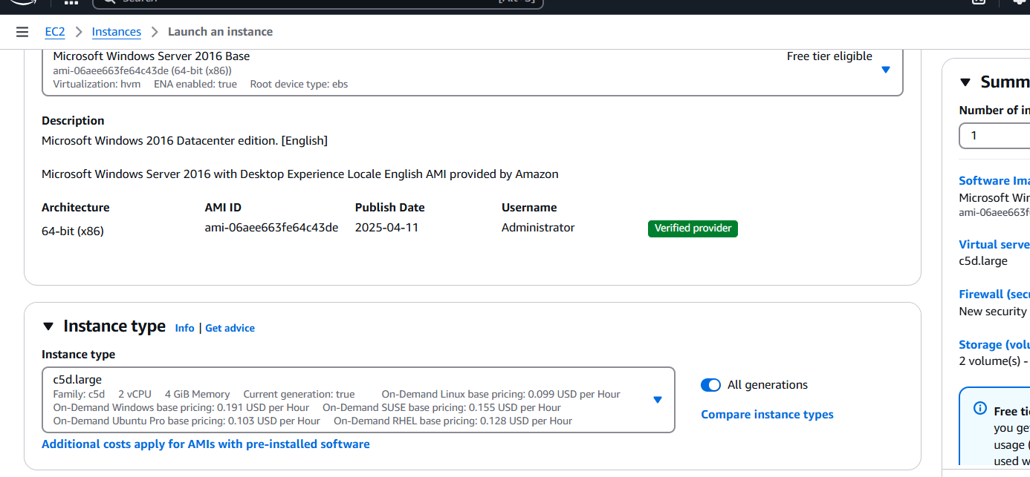
2. Connect to the Windows instance:
Open Disk Management:
Look for a disk that is uninitialized
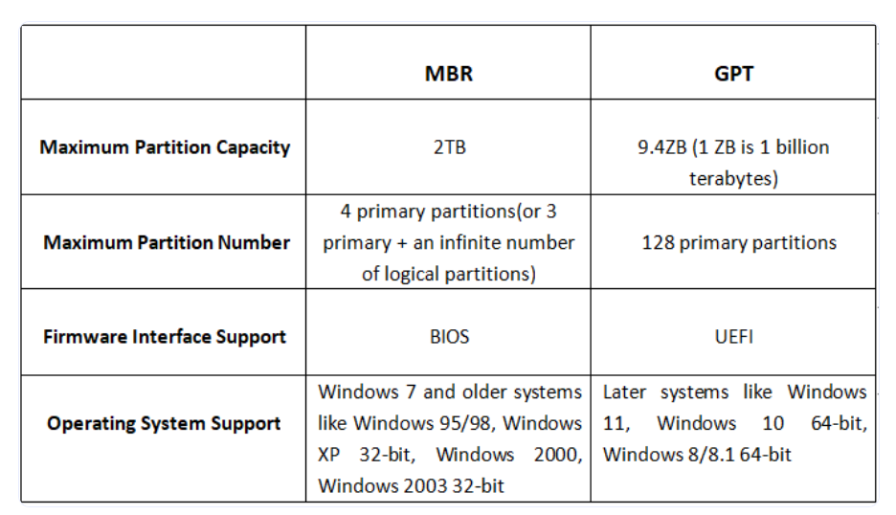
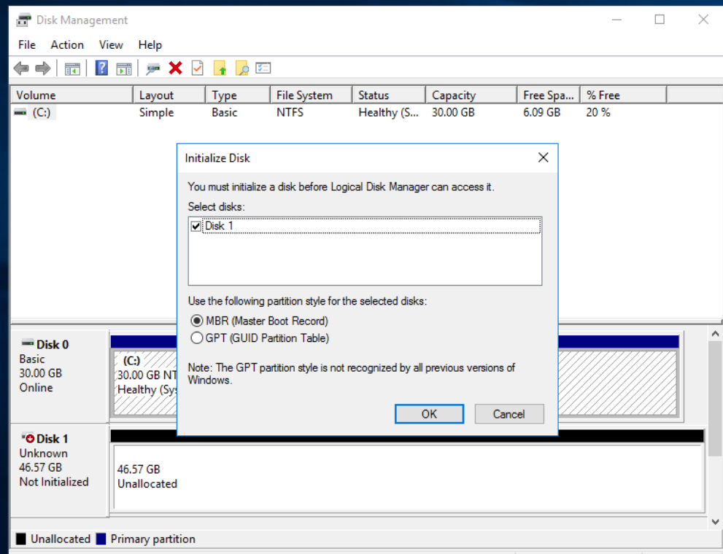
3. Initialize and format the disk:
Right-click the unallocated disk → Initialize Disk
Create a New Simple Volume
Format with NTFS and assign a drive letter
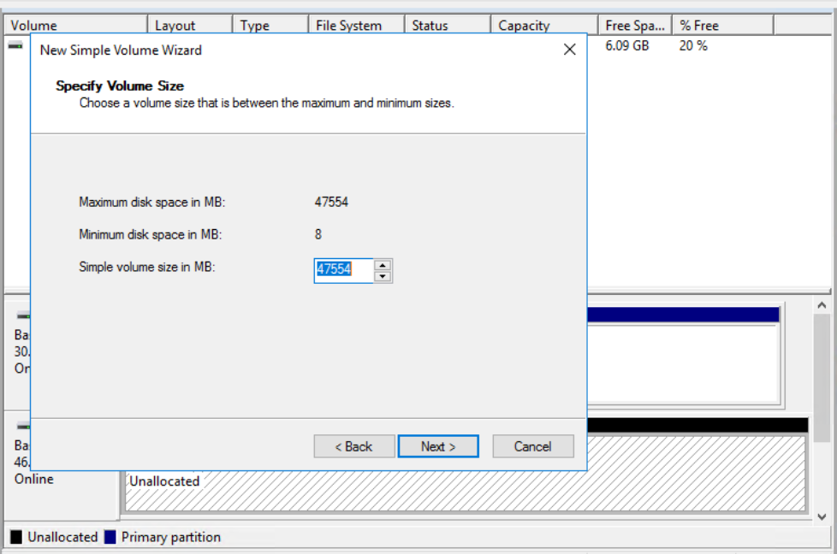
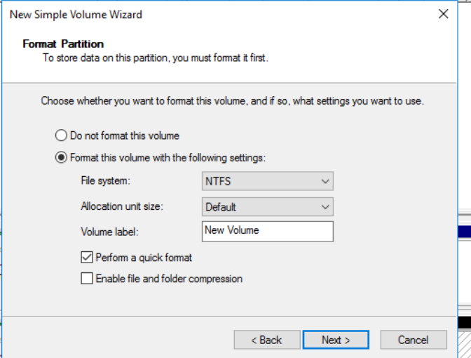
4. Test the instance store:
Copy a large file or generate dummy data into the new drive:
powershell
fsutil file createnew D:\testfile.txt 100000000
(Creates a ~100MB file)
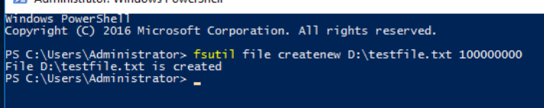
- Reboot the instance to check if data persists (it should).
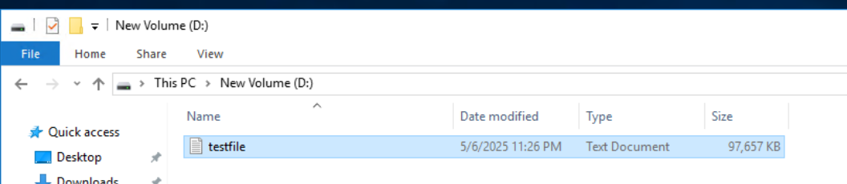
- Stop and start the instance from EC2 console (not reboot).

- After start, check if `D\` drive is empty or missing — this confirms it's ephemeral.
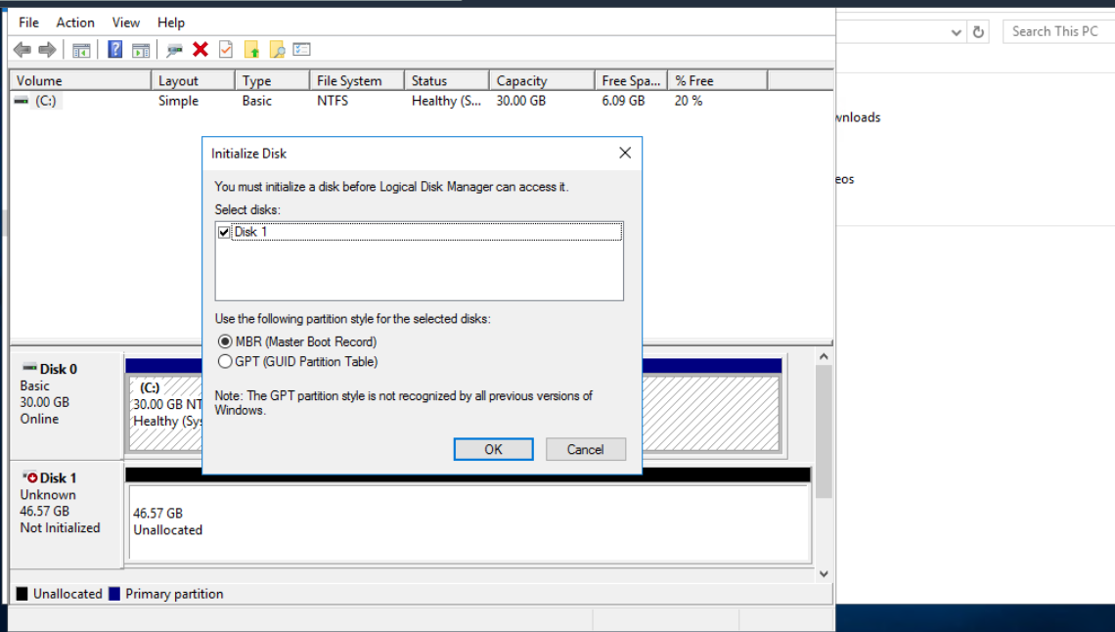

Important:
Reboot preserves instance store.
Stop/start or terminate will erase data in instance store.

